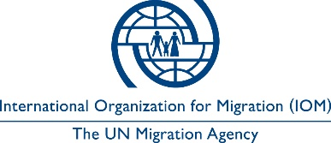

Open to Internal and External Candidates
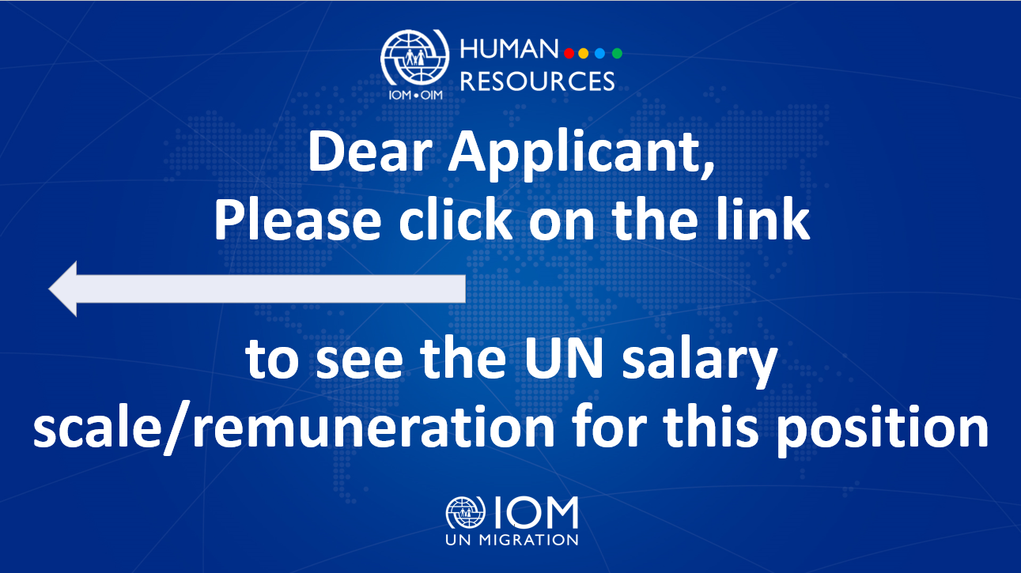

Position Title | : | Project Assistant (TRD)
Duty Station | : | Dnipro, Ukraine
Classification | : | General Service Staff, Grade G4
Type of Appointment | : | Special Short-Term, Six months with the  possibility of extension
Estimated Start Date | : | As soon as possible
Closing Date | : | 21 June 2023

Established in 1951, IOM is a Related Organization of the United Nations, and as the leading UN agency in the field of migration, works closely with governmental, intergovernmental and non-governmental partners. IOM is dedicated to promoting humane and orderly migration for the benefit of all. It does so by providing services and advice to governments and migrants.

IOM is committed to a diverse and inclusive environment. Internal and external candidates are eligible to apply to this vacancy. For the purpose of the vacancy, internal candidates are considered as first-tier candidates.

Context:

Under overall supervision of the Chief of Mission and Senior Programme Coordinator (RRR), with the direct supervision of the Project Officer (Reintegration), the Project Assistant will be responsible for providing necessary support and contributions to the implementation of IOM’s response, recovery and resilience efforts.

Core Functions / Responsibilities:
- Assist in the overall implementation of response, recovery and resilience efforts.
- Aid project specialists in contracting partners, assist in procurement of goods and services.
- Support project specialists in regular reporting (IOM internal, IOM external, UN-related, including 3W and situation reporting), correspondence, publication and presentation materials.
- Assist in the logistics and organization of Response, Recovery and Resilience-related activities and events (meetings, presentations, discussions, visits, etc.).
- Provide informal interpretation and written translation (English/Ukrainian, Russian as well) when necessary.
- Draft official and unofficial correspondence in English and Ukrainian (Russian if necessary).
- Take notes at relevant programme events.
- Render support to programme visibility as necessary.
- Undertake duty travel within Ukraine, to areas selected for Response, Recovery and Resilience programming, on an as-needed basis.
- Perform other relevant duties as may be assigned.
Required Qualifications and Experience
Education

- High school diploma/certificate or equivalent with at least four years of relevant work experience;
OR
- Bachelor’s degree or equivalent in Political or Social Sciences, International Relations, Development Studies, Migration Studies, Human Rights, Law or related fields from an accredited academic institution with two years of relevant professional experience.

Experience

- Experience in working with vulnerable groups, for example veterans, people with disabilities, migrants, refugees, internally displaced persons, victims of trafficking and/or other;
- Experience of working in a UN agency or International NGO is an asset;
- Experience of working with governmental authorities and NGOs;
- Experience of field work and assessment;
- Experience of general administration;
- Knowledge of community stabilization, social cohesion, livelihood, recovery, and similar activities;
- Ability to implement administrative and financial control procedures;
- Confident user of the Microsoft Office Suite.

Languages

English and Ukrainian is required.

The incumbent is expected to demonstrate the following values and competencies:

Values
- Inclusion and respect for diversity: respects and promotes individual and cultural differences; encourages diversity and inclusion wherever possible.
- Integrity and transparency: maintains high ethical standards and acts in a manner consistent with organizational principles/rules and standards of conduct.
- Professionalism: demonstrates ability to work in a composed, competent and committed manner and exercises careful judgment in meeting day-to-day challenges.

Core Competencies – behavioural indicators
- Teamwork: develops and promotes effective collaboration within and across units to achieve shared goals and optimize results.
- Delivering results: produces and delivers quality results in a service-oriented and timely manner; is action oriented and committed to achieving agreed outcomes.
- Managing and sharing knowledge: continuously seeks to learn, share knowledge and innovate.
- Accountability: takes ownership for achieving the Organization’s priorities and assumes responsibility for own action and delegated work.
- Communication: encourages and contributes to clear and open communication; explains complex matters in an informative, inspiring and motivational way.

Other

Any offer made to the candidate in relation to this vacancy notice is subject to funding confirmation.

Appointment will be subject to certification that the candidate is medically fit for appointment and security clearances.

A prerequisite for taking up the position is legal residency in the country of the duty station and work permit, as applicable.

How to apply:

Interested candidates are invited to submit their applications filling in the IOM Personal History Form and sending to iomukrainerecruitment@iom.int by 21 June 2023 the latest, referring to this advertisement in the subject line of your message.

Only shortlisted candidates will be contacted.

Posting period:
From 07.06.2023 to 21.06.2023

