Open to Internal and External Candidates
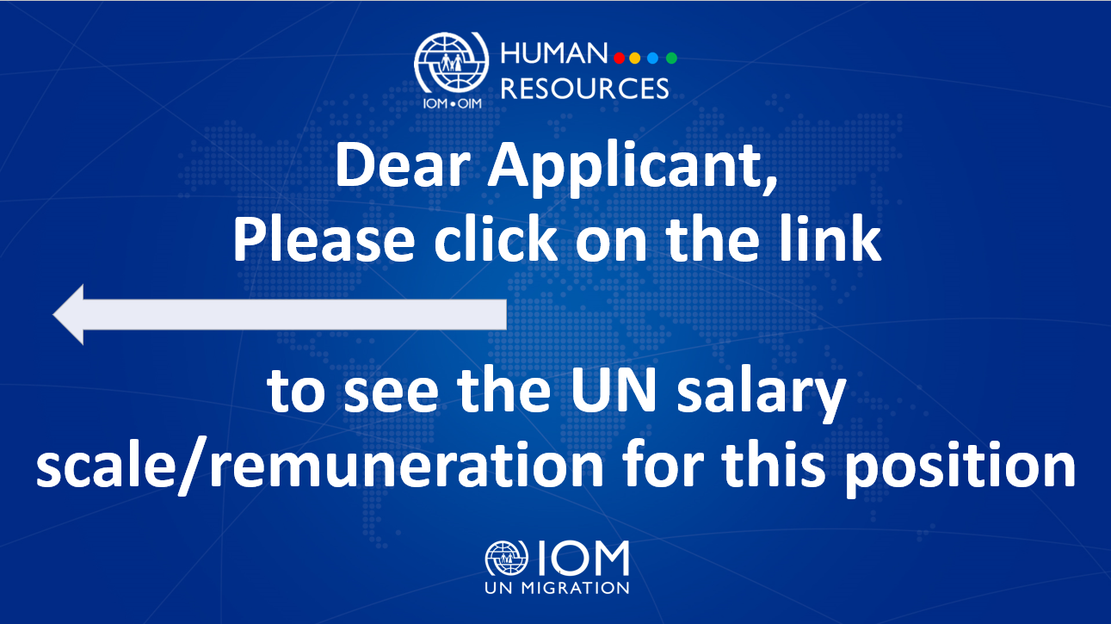

Position Title | : | M&E Assistant
Duty Station | : | Lviv, Ukraine
Classification | : | General Service Staff, Grade G4
Type of Appointment | : | Special Short-Term, Six months with the  possibility of extension
Estimated Start Date | : | As soon as possible
Closing Date | : | 17 June 2023

Established in 1951, IOM is a Related Organization of the United Nations, and as the leading UN agency in the field of migration, works closely with governmental, intergovernmental and non-governmental partners. IOM is dedicated to promoting humane and orderly migration for the benefit of all. It does so by providing services and advice to governments and migrants.

IOM is committed to a diverse and inclusive environment. Internal and external candidates are eligible to apply to this vacancy. For the purpose of the vacancy, internal candidates are considered as first-tier candidates.

Context:

Under the overall supervision of the Chief of Mission and the Monitoring and Evaluation Officer, and direct supervision of the Monitoring and Evaluation Support Officer, the successful candidate will provide general support to the implementation of IOM Mission in Ukraine’s efforts with regard to reporting, monitoring and evaluation.

Core Functions / Responsibilities:

- Participate in drafting data collection tools, templates, and assist in regular data collection process.
- Assist in maintaining relevant databases.
- Collaborate across various project teams to support timely collection of data on project activities and providing M&E related training if needed.
- Undertake duty travels within Ukraine to conduct post distribution monitoring of implemented activities and to establish links with focal points in various communities for data collection purposes.
- Assist in compiling M&E reports, contributing to ad hoc project progress reports, evaluation reports by providing M&E related information.
- Assist in collecting survey responses, case stories, best practice documentation, lessons learned; updating and maintaining that information in project's reports and other knowledge products.
- Participate in virtual and offline internal and external monitoring through assisting in organizing and facilitating various events such as meetings, workshops, conferences, and seminars.
- Perform such other duties as may be assigned.

Required Qualifications and Experience
Education

- High school diploma/certificate or equivalent with at least four years of relevant work experience; or
- Bachelor’s degree in Political or Social Sciences, International Relations, Development Studies, Migration Studies, Human Rights, Law or related fields from an accredited academic institution with two years of relevant professional experience.

Experience

- Experience in liaising with governmental authorities, national/international institutions, United Nations agencies and non-governmental organizations.
- Experience in working with migrants, refugees, internally displaced persons, victims of trafficking and other vulnerable groups.
- Prior work experience with international humanitarian organizations, non-government or government institutions/organization in a multi-cultural setting is an advantage.

Skills

- Proficient in Microsoft Office applications e.g. Word, Excel, PowerPoint, E-mail, Outlook.
- Attention to detail, ability to organize paperwork in a methodical way.
- Discreet, details and clients-oriented, patient and willingness to learn new things.

Languages

For all applicants, fluency in Ukrainian is required (oral and written).
Working knowledge of English is required.

Competencies

The incumbent is expected to demonstrate the following values and competencies:

Values
- Inclusion and respect for diversity: Respects and promotes individual and cultural differences. Encourages diversity and inclusion.
- Integrity and transparency: Maintains high ethical standards and acts in a manner consistent with organizational principles/rules and standards of conduct.
- Professionalism: Demonstrates ability to work in a composed, competent and committed manner and exercises careful judgment in meeting day-to-day challenges.
- Courage: Demonstrates willingness to take a stand on issues of importance.
- Empathy: Shows compassion for others, makes people feel safe, respected and fairly treated.

Core Competencies – behavioural indicators level 1
- Teamwork: develops and promotes effective collaboration within and across units to achieve shared goals and optimize results.
- Delivering results: produces and delivers quality results in a service-oriented and timely manner; is action oriented and committed to achieving agreed outcomes.
- Managing and sharing knowledge: continuously seeks to learn, share knowledge and innovate.
- Accountability: takes ownership for achieving the Organization’s priorities and assumes responsibility for own action and delegated work.
- Communication: encourages and contributes to clear and open communication; explains complex matters in an informative, inspiring and motivational way.

Other

Any offer made to the candidate in relation to this vacancy notice is subject to funding confirmation.

Appointment will be subject to certification that the candidate is medically fit for appointment and security clearances.

A prerequisite for taking up the position is legal residency in the country of the duty station and work permit, as applicable.

How to apply:

Interested candidates are invited to submit their applications filling in the IOM Personal History Form and sending to iomukrainerecruitment@iom.int by 17 June 2023 the latest, referring to this advertisement in the subject line of your message.

Only shortlisted candidates will be contacted.

Posting period:
From 08.06.2023 to 17.06.2023

