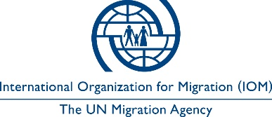

Open to Internal and External Candidates
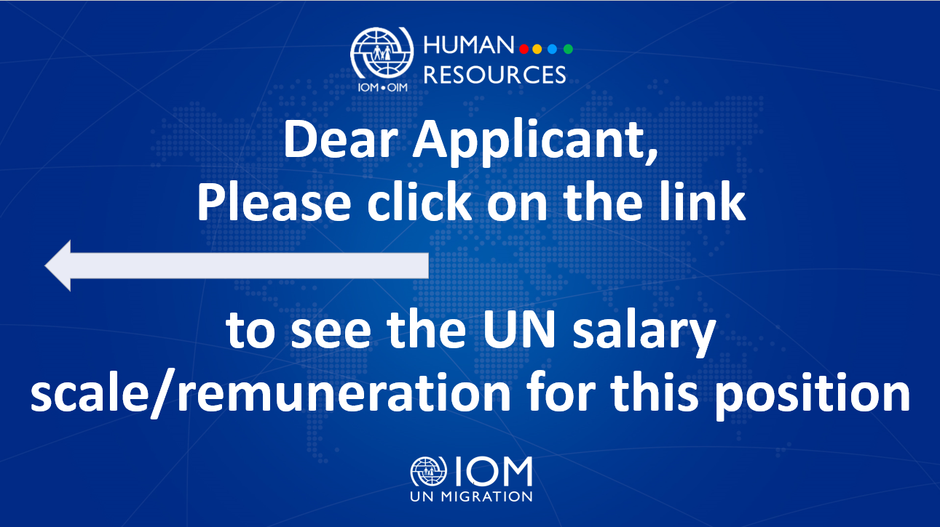

Position Title | : | Communications Specialist
Duty Station | : | Ivano-Frankivsk, Ukraine
Classification | : | General Service Staff, Grade G6
Type of Appointment | : | Special Short-Term, Six months with the  possibility of extension
Estimated Start Date | : | As soon as possible
Closing Date | : | 20 June 2023

Established in 1951, IOM is a Related Organization of the United Nations, and as the leading UN agency in the field of migration, works closely with governmental, intergovernmental and non-governmental partners. IOM is dedicated to promoting humane and orderly migration for the benefit of all. It does so by providing services and advice to governments and migrants.

IOM is committed to a diverse and inclusive environment. Internal and external candidates are eligible to apply to this vacancy. For the purpose of the vacancy, internal candidates are considered as first-tier candidates.

Context:

Under the overall supervision of the Chief of Mission and the Deputy Chief of Mission (Management) and the direct supervision of the National Communications Officer, in coordination with Communications and Outreach Response staff deployed in Ukraine as well as the IOM Coordinator of Regional Hub of Humanitarian Response, the incumbent will work to ensure effective implementation of IOM Ukraine communications and outreach strategy on humanitarian response provided in the context of the current crisis.

Core Functions / Responsibilities:

- Assist the Communications Team and Ivano-Frankivsk and Chernivtsi hubs for humanitarian response to prepare an outreach and visibility plan for delivery of HA in Ivano-Frankivsk and Chernivtsi Regions.
- Reach out to implementing partners (IPs) in Ivano-Frankivsk and Chernivtsi Regions, and other regions covered by the designated IOM hubs, to inform and instruct on IOM visibility guidelines regarding distribution of HA; train IPs when needed on how to ensure maximum visibility of IOM HA support.
- Ensure visibility of all HA activities (such as distribution of NFIs, shelter and WASH activities, etc.) and other IOM activities implemented in the targeted regions. This entails attending the planned events, taking photos, preparing press releases, ensuring local media presence, conducting interviews with key stakeholders and beneficiaries, drafting human interest stories, documenting all events; preparing posts for social media platforms (Facebook, Instagram, LinkedIn, Twitter) and website.
- Prepare periodic observation reports on HA activities, outlining actions taken on communications and visibility, challenges faced and lessons learned.
- Contribute to drafting and editing of the Mission’s and individual programmes’/projects’ newsletter/circular, promotional, visibility, analytical, and administrative publications, products, and materials as requested.
- Take the lead in the organization of public awareness campaigns in the designated region.
- Draft articles, briefs, press announcements, press releases, and responses to media inquiries related to the work of the Mission in the targeted region.
- Liaise with external photographers, video production companies, etc. to ensure high quality photo and video materials on the wide range of the Mission activities in the designated region.
- Liaise with local media and communications counterparts.
- Provide Ukrainian-English and English-Ukrainian informal translation of various documents and materials, when necessary.
- Perform such other duties as may be assigned.

Required Qualifications and Experience
Education

- High school degree or equivalent with six years of relevant working experience or
- Bachelor’s Degree in Communications, Marketing, Journalism or in related field from an accredited academic institution with at least four years of relevant professional experience.
- Excellent written and oral communication and interpersonal skills;
- Excellent knowledge of social media platforms/principles and experience in social media and outreach management including understanding of development of content and digital media and communications strategies for outreach purposes;
- Excellent writing and editing skills in Ukrainian and English;
- Graphic design, photo and/or video editing skills will be an advantage.

Languages

Fluency in English and Ukrainian – required.

The incumbent is expected to demonstrate the following values and competencies:

Values
- Inclusion and respect for diversity: respects and promotes individual and cultural differences; encourages diversity and inclusion wherever possible.
- Integrity and transparency: maintains high ethical standards and acts in a manner consistent with organizational principles/rules and standards of conduct.
- Professionalism: demonstrates ability to work in a composed, competent and committed manner and exercises careful judgment in meeting day-to-day challenges.

Core Competencies – behavioural indicators
- Teamwork: develops and promotes effective collaboration within and across units to achieve shared goals and optimize results.
- Delivering results: produces and delivers quality results in a service-oriented and timely manner; is action oriented and committed to achieving agreed outcomes.
- Managing and sharing knowledge: continuously seeks to learn, share knowledge and innovate.
- Accountability: takes ownership for achieving the Organization’s priorities and assumes responsibility for own action and delegated work.
- Communication: encourages and contributes to clear and open communication; explains complex matters in an informative, inspiring and motivational way.

Other

Any offer made to the candidate in relation to this vacancy notice is subject to funding confirmation.

Appointment will be subject to certification that the candidate is medically fit for appointment and security clearances.

A prerequisite for taking up the position is legal residency in the country of the duty station and work permit, as applicable.

How to apply:

Interested candidates are invited to submit their applications filling in the IOM Personal History Form and sending to iomukrainerecruitment@iom.int by 20 June 2023 the latest, referring to this advertisement in the subject line of your message.

Only shortlisted candidates will be contacted.

Posting period:
From 06.06.2023 to 20.06.2023

