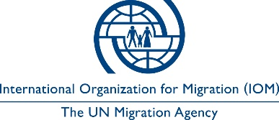

Open to Internal and External Candidates
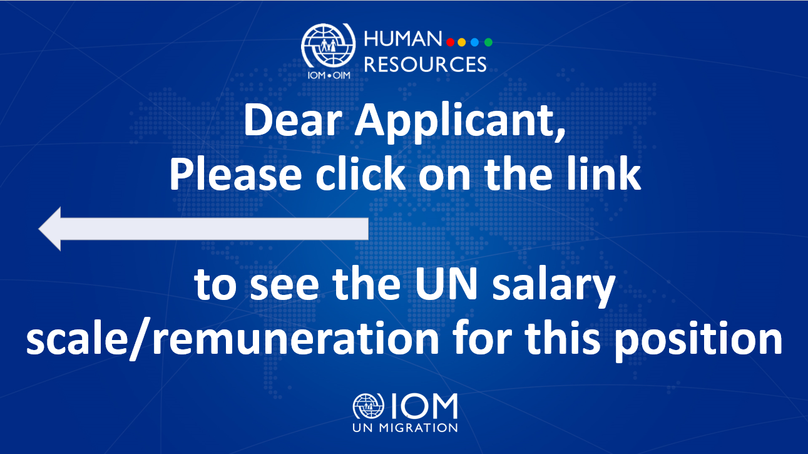

Position Title | : | Senior Graphic Designer  (Data and analytics)
Duty Station | : | Kyiv, Ukraine
Classification | : | General Service Staff, Grade G7
Type of Appointment | : | Special Short-Term, Nine months with the  possibility of extension
Estimated Start Date | : | As soon as possible
Closing Date | : | 16 June 2023

Established in 1951, IOM is a Related Organization of the United Nations, and as the leading UN agency in the field of migration, works closely with governmental, intergovernmental and non-governmental partners. IOM is dedicated to promoting humane and orderly migration for the benefit of all. It does so by providing services and advice to governments and migrants.

IOM is committed to a diverse and inclusive environment. Internal and external candidates are eligible to apply to this vacancy. For the purpose of the vacancy, internal candidates are considered as first-tier candidates.

Context:

Since 2014, the IOM Data and Analytics team has been collecting, analysing and reporting on humanitarian needs in Ukraine. The scale of displacement and humanitarian needs across Ukraine remain extremely high. As a result, there is a high demand for timely and credible information on the location, intentions, needs and situation of vulnerable communities across the country. The IOM Data and Analytics team support all organisations engaged in delivering services and support to those communities with data which is presented in a format that is both engaging and actionable.

Under the overall supervision of the Chief of Mission and Programme Manager (IM & MEL), and the direct supervision of the Reporting Officer, the successful candidate will support the Data and Analytics (D&A) Unit’s efforts to deliver graphic design work for all D&A products and needs, including those related to reports capturing the results of Displacement Tracking Matrix (DTM) and other types of assessments.

Core Functions / Responsibilities:

- Design and develop layouts and templates for research studies, reports, infographics, dashboards, public information materials, social media images, etc. to support the strategic communication of the D&A Unit on the data collected in Ukraine to monitor the displacement and mobility of the population, as well as the priority needs and the main socio-economic conditions resulting from the ongoing war.
- Assist the D&A Reporting team in the production of analytical and reporting products and the D&A Unit staff in preparing presentations, including in Adobe InDesign, PowerPoint, Publisher, and Prezi, based on internal/external requests as well as designing wireframes for internal and external websites and portals using Adobe XD.
- Ensure compliance of all the materials with IOM, IOM Global Migration Data Analysis Centre (GMDAC), DTM, and donor brand guidelines.
- Act as a focal point for the production, editing and adaptation of visual text and images for all D&A creative content for online campaigns, print ads, websites, videos, and other visibility materials through professional software such as Adobe InDesign, Photoshop, Illustrator etc., and other online available applications such as Canva.
- Maintain and verify copyright free or properly licensed content, cultural sensitivities, human rights approach and a gender focus in all communications materials.
- Support the D&A IM officer and reporting team in ensuring the implementation and adaptation, as needed, of information visualization tools that meet the needs of partners and other humanitarian actors.
- In coordination with Programme Support staff, facilitate coordination of the work with external vendors, printing companies, etc.
- Perform technical trainings to strengthen graphic design skills for IOM and counterparts´ staff in basic concepts of graphic design, use and combination of colors, development of infographics, as well as graphic design software such as Adobe Photoshop and Illustrator. Additionally, support the organization of project-related meetings and workshops.
- Perform such other duties as may be assigned.

Required Qualifications and Experience
Education

- Bachelor’s Degree in Graphic Design, Communications or a related field from an accredited academic institution with at least five years of relevant professional experience; or
- High School Degree/Certificate with seven years of relevant professional experience.
Experience
- In-depth knowledge of and expertise in a wide range of Adobe Creative Suite software applications such as InDesign, Illustrator, Photoshop and Dreamweaver is required.
- Relevant and demonstrable academic and practical experience in the field of graphic design is required.
- Experience and skill in data visualization will be considered a significant advantage.
- Experience with additional visualization software such as tableau and Power BI is an advantage.
- A portfolio demonstrating knowledge of graphic design layout and reporting products, including photographic requirements and procedures.
- Ability to identify and interpret graphic and web design needs and develop creative and responsive design concepts.
- Ability to develop complex, integrated design, printing, and/or reproduction specifications.
- Ability to compile and prepare graphic production budgets, schedules, and workplans.
- Knowledge of available external graphic design, printing, publication, and associated resources.
- Pro-active team player who can work with web developers, web designers and production colleagues under pressure to tight deadlines.
- Ability to multi-task, can work independently and think strategically.
- Good organizational skills with the ability to prioritize and an eye for detail.
- Knowledge of principles and practices of graphic design.
- Ability to create and produce graphic materials using a range of media, methods, techniques, and equipment.
- Ability to communicate effectively, both orally and in writing.
- Ability to supervise and train assigned staff.

Languages

For this position, fluency in English and Ukrainian is required (oral and written).

The incumbent is expected to demonstrate the following values and competencies:

Values
- Inclusion and respect for diversity: respects and promotes individual and cultural differences; encourages diversity and inclusion wherever possible.
- Integrity and transparency: maintains high ethical standards and acts in a manner consistent with organizational principles/rules and standards of conduct.
- Professionalism: demonstrates ability to work in a composed, competent and committed manner and exercises careful judgment in meeting day-to-day challenges.

Core Competencies – behavioural indicators level 2
- Teamwork: develops and promotes effective collaboration within and across units to achieve shared goals and optimize results.
- Delivering results: produces and delivers quality results in a service-oriented and timely manner; is action oriented and committed to achieving agreed outcomes.
- Managing and sharing knowledge: continuously seeks to learn, share knowledge and innovate.
- Accountability: takes ownership for achieving the Organization’s priorities and assumes responsibility for own action and delegated work.
- Communication: encourages and contributes to clear and open communication; explains complex matters in an informative, inspiring and motivational way.

Other

Any offer made to the candidate in relation to this vacancy notice is subject to funding confirmation.

Appointment will be subject to certification that the candidate is medically fit for appointment and security clearances.

A prerequisite for taking up the position is legal residency in the country of the duty station and work permit, as applicable.

How to apply:

Interested candidates are invited to submit their applications filling in the IOM Personal History Form and sending to iomukrainerecruitment@iom.int by 16 June 2023 the latest, referring to this advertisement in the subject line of your message.

Only shortlisted candidates will be contacted.

Posting period:
From 02.06.2023 to 16.06.2023.

