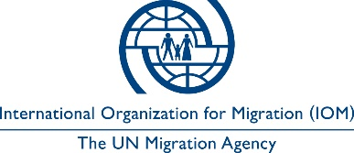

Open to Internal and External Candidates
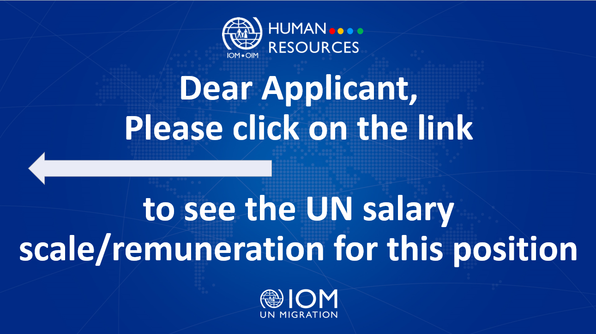

Position Title | : | Communications Assistant (Public  Information)
Duty Station | : | Kyiv, Ukraine
Classification | : | General Service Staff, Grade G5
Type of Appointment | : | Special Short-Term, Six months with the  possibility of extension
Estimated Start Date | : | As soon as possible
Closing Date | : | 14 June 2023

Established in 1951, IOM is a Related Organization of the United Nations, and as the leading UN agency in the field of migration, works closely with governmental, intergovernmental and non-governmental partners. IOM is dedicated to promoting humane and orderly migration for the benefit of all. It does so by providing services and advice to governments and migrants.

IOM is committed to a diverse and inclusive environment. Internal and external candidates are eligible to apply to this vacancy. For the purpose of the vacancy, internal candidates are considered as first-tier candidates.

Context:

Under the overall supervision of the Chief of Mission and the Policy, Liaison and Project Development Coordinator, and the direct supervision of the National Communications Officer, the Communications Assistant (Public Information) will contribute to the successful implementation of IOM Ukraine’s communications and outreach activities.

Core Functions / Responsibilities:
- Assist in implementing/organizing communications and outreach activities to foster IOM’s visibility among its governmental, non-governmental, international partners and the Ukrainian society providing for the efficiency and sustainability of the Mission’s external and internal communications and supporting the organization’s objectives.
- In coordination with IOM Ukraine’s Policy, Liaison and Project Development (PLPD) team, collaborate with other Units to facilitate information sharing and enhance external communications efforts, making sure that design and messaging is appropriate and relevant for the target groups.
- Support audio and visual needs of events, website(s) and publications.
- Liaise with external photographers, video production companies, etc. to ensure high quality photo and video materials on the wide range of the Mission activities in the country.
- Facilitate the preparation of the Mission’s and individual programme/project information and promotional materials and publications by assisting with monitoring the work of external designers as well as printing companies/service providers.
- Conduct initial editing/proofreading and translation of documents and publications.
- In coordination with the supervisor, maintain and update the Mission’s online resources, ensuring sustainable and timely dissemination of the Mission’s key messages.
- Participate in assessment of the effectiveness of visibility products and actions to gauge outreach success, identify and suggest most effective methods to maximize IOM visibility and work on new approaches to promote IOM impact.
- Support IOM’s needs in virtual meeting environments, particularly outreach activities such as high-profile public events, press briefings and outreach activities.
- Participate in coordination and organization of meetings, major exhibits/events and press conferences. Provide logistical and administrative coordination for the implementation of communication activities and events.
- Provide administrative support, particularly with drafting Terms of Reference or Technical Specifications on visibility-related issues and assessing capacity of potential vendors.
- Support in preparing the communications budget and monitoring its execution.
- Undertake duty travel as required and perform such other duties as may be assigned.
- Perform such other duties as may be assigned.

Required Qualifications and Experience
Education

- High school diploma with five years of relevant experience; or,
- Bachelor’s degree in in Journalism, Social or Political Sciences or related fields from an accredited institution with three years of relevant professional experience.

Experience

- Experience in media, PR, and administrative duties;
- Attention to detail, ability to organize paperwork in a methodical way;
- Discreet, details and clients-oriented, patient and willingness to learn new things; and,
- Prior work experience with international humanitarian organizations, non-government or government institutions/organization in a multi-cultural setting is an advantage.
- Confident writing and editing skills in Ukrainian and English.
- Confident use of professional graphic design programmes (Adobe Photoshop, Adobe Illustrator) and Publisher is an advantage.

Languages

Fluency in English and Ukrainian is required.

The incumbent is expected to demonstrate the following values and competencies:

Values
- Inclusion and respect for diversity: respects and promotes individual and cultural differences; encourages diversity and inclusion wherever possible.
- Integrity and transparency: maintains high ethical standards and acts in a manner consistent with organizational principles/rules and standards of conduct.
- Professionalism: demonstrates ability to work in a composed, competent and committed manner and exercises careful judgment in meeting day-to-day challenges.

Core Competencies – behavioural indicators
- Teamwork: develops and promotes effective collaboration within and across units to achieve shared goals and optimize results.
- Delivering results: produces and delivers quality results in a service-oriented and timely manner; is action oriented and committed to achieving agreed outcomes.
- Managing and sharing knowledge: continuously seeks to learn, share knowledge and innovate.
- Accountability: takes ownership for achieving the Organization’s priorities and assumes responsibility for own action and delegated work.
- Communication: encourages and contributes to clear and open communication; explains complex matters in an informative, inspiring and motivational way.

Other

Any offer made to the candidate in relation to this vacancy notice is subject to funding confirmation.

Appointment will be subject to certification that the candidate is medically fit for appointment and security clearances.

A prerequisite for taking up the position is legal residency in the country of the duty station and work permit, as applicable.

How to apply:

Interested candidates are invited to submit their applications filling in the IOM Personal History Form and sending to iomukrainerecruitment@iom.int by 14 June 2023 the latest, referring to this advertisement in the subject line of your message.

Only shortlisted candidates will be contacted.

Posting period:
From 31.05.2023 to 14.06.2023

