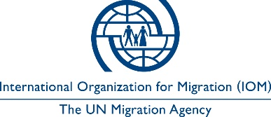

Open to Internal and External Candidates
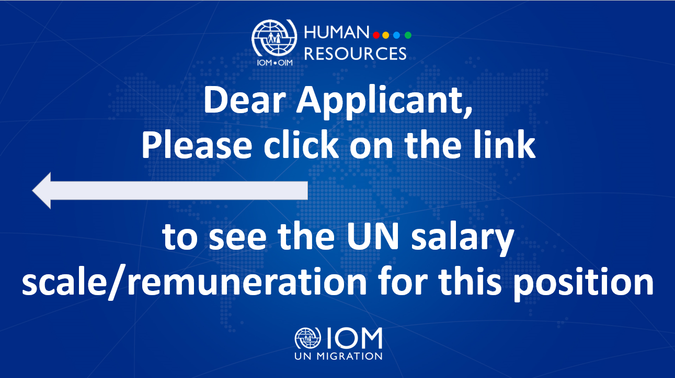

Position Title | : | Protection Field Assistant
Duty Station | : | Kyiv, Ukraine
Classification | : | General Service Staff, Grade G4
Type of Appointment | : | Special Short-Term, Six months with the  possibility of extension
Estimated Start Date | : | As soon as possible
Closing Date | : | 16 June 2023

Established in 1951, IOM is a Related Organization of the United Nations, and as the leading UN agency in the field of migration, works closely with governmental, intergovernmental and non-governmental partners. IOM is dedicated to promoting humane and orderly migration for the benefit of all. It does so by providing services and advice to governments and migrants.

IOM is committed to a diverse and inclusive environment. Internal and external candidates are eligible to apply to this vacancy. For the purpose of the vacancy, internal candidates are considered as first-tier candidates.

Context:

Under the overall supervision of Chief of Mission and direct supervision of the Protection Field Leader, the incumbent will be responsible for implementing IOM Ukraine’s Protection Programming at the oblast/area level, applying protection principles and techniques, interagency and cluster guidelines, adhering to IOM standards and procedures, and collaborating with IOM teams, NGOs, authorities and other relevant partners.

Core Functions / Responsibilities:

- Assist individual protection cases, by identifying the needs of extremely vulnerable individuals, coordinating assistance for protection cases, and supporting referrals to specialized services for victims of trafficking, GBV survivors, and child with protection needs.
- Support the implementation of IOM protection activities that deliver a high-quality service to beneficiaries. Key tasks may include interacting with the community daily, raising awareness on protection issues among communities, monitoring protection incidents, and conducting protection mainstreaming activities.
- Conduct frequent field visits to IDP sites and other conflict-affected locations to observe, identify, and collect information on the situation, taking into special account vulnerable people, noting and reporting on gaps that may exist in any humanitarian service access and provision.
- Identify protection issues and report to the Senior Protection Field Leader for referral to the relevant actors.

- Assist supervisors in representing IOM Protection by, for example, participating and contributing to site settlement and cluster related meetings, donor visits, and interacting with relevant partners on Protection issues.

- Support IOM with establishing community-based protection activities that engage community members, including those persons who are often underserved such as older persons, youth, and persons with disabilities to foster community protection.
- Assist supervisors with reporting and administration of field activities, such procurement matters, data collection and entry for reporting writing, and collaborating with colleagues to meet deadlines, and identifying programmatic gaps.
- Maintain positive working relationships with relevant stakeholders including community leaders, partners, government officials, other sector staff and other implementing organizations on the ground.
- Undertake duty travel based on programme needs.
- Perform such other duties as may be assigned.

Required Qualifications and Experience
Education

- Bachelor’s Degree with Social Sciences, International Relations, Political Science, Education, Law or International Relations or related field from an accredited academic institution with at least two years of relevant work experience

OR
- High School Degree/Certificate with four years of relevant work experience
Experience

- Experience with social work, case management processes, and assisting persons in need.
- Familiarity with humanitarian operational responses, internal displacement, and Protection Principles.
- Previous work experience in a governmental, UN or NGO that deals with humanitarian and/or development work is preferable.
- Excellent attention to detail and deadlines.
- Strong organizational skills (logistics, procedures, archives)
- Good understanding of English, as well as communication and writing skills in English.
- Proficiency in computer skills, especially in MS Office (Excel, Outlook, Word etc.) and experience in working with databases and online applications.
- Ability to learn new thematic areas, such as those related to IOM’s protection work.
Languages

Fluency in English and Ukrainian (oral and written). Russian is desirable.

The incumbent is expected to demonstrate the following values and competencies:

Values
- Inclusion and respect for diversity: respects and promotes individual and cultural differences; encourages diversity and inclusion wherever possible.
- Integrity and transparency: maintains high ethical standards and acts in a manner consistent with organizational principles/rules and standards of conduct.
- Professionalism: demonstrates ability to work in a composed, competent and committed manner and exercises careful judgment in meeting day-to-day challenges.

Core Competencies – behavioural indicators
- Teamwork: develops and promotes effective collaboration within and across units to achieve shared goals and optimize results.
- Delivering results: produces and delivers quality results in a service-oriented and timely manner; is action oriented and committed to achieving agreed outcomes.
- Managing and sharing knowledge: continuously seeks to learn, share knowledge and innovate.
- Accountability: takes ownership for achieving the Organization’s priorities and assumes responsibility for own action and delegated work.
- Communication: encourages and contributes to clear and open communication; explains complex matters in an informative, inspiring and motivational way.

Other

Any offer made to the candidate in relation to this vacancy notice is subject to funding confirmation.

Appointment will be subject to certification that the candidate is medically fit for appointment and security clearances.

A prerequisite for taking up the position is legal residency in the country of the duty station and work permit, as applicable.

How to apply:

Interested candidates are invited to submit their applications filling in the IOM Personal History Form and sending to iomukrainerecruitment@iom.int by 16 June 2023 the latest, referring to this advertisement in the subject line of your message.

Only shortlisted candidates will be contacted.

Posting period:
From 09.06.2023 to 16.06.2023

