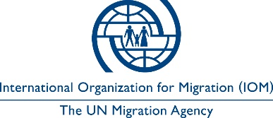

Open to Internal and External Candidates
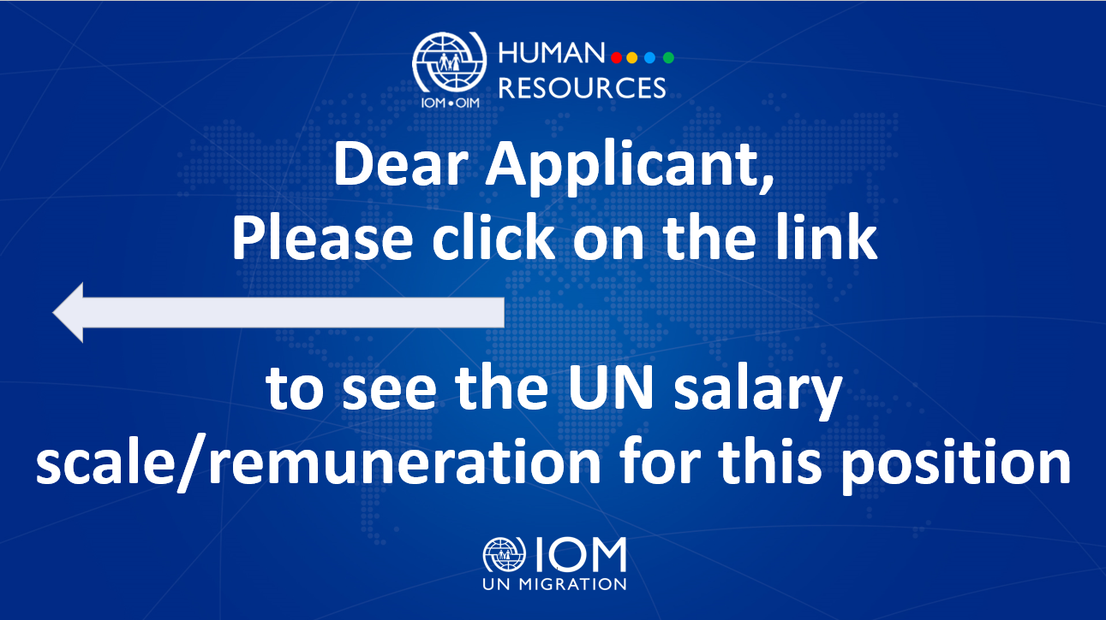
Position Title | : | Senior Project Assistant (NFI and CP Supplies Management)
Duty Station | : | Uzhhorod, Ukraine
Classification | : | General Service Staff, Grade G6
Type of Appointment | : | Special Short-Term, Nine months with the  possibility of extension
Estimated Start Date | : | As soon as possible
Closing Date | : | 14 June 2023

Established in 1951, IOM is a Related Organization of the United Nations, and as the leading UN agency in the field of migration, works closely with governmental, intergovernmental and non-governmental partners. IOM is dedicated to promoting humane and orderly migration for the benefit of all. It does so by providing services and advice to governments and migrants.

IOM is committed to a diverse and inclusive environment. Internal and external candidates are eligible to apply to this vacancy. For the purpose of the vacancy, internal candidates are considered as first-tier candidates.

Context:

The intensity of the armed violence in Ukraine is having a severe humanitarian impact on the population. The conflict has resulted in loss of life, injuries, and mass movement of civilian population throughout the country and to neighbouring countries, as well as severe destruction and damage to civilian infrastructure and residential housing.

In summary, according to OCHA reports, with the scale and direction of the ongoing military operation, 18 million people are projected to become affected, including up to 6.7 million people projected to be newly internally displaced. Of the affected population, 12 million people are expected to need humanitarian assistance, and 6 million with the most urgent humanitarian needs – including shelter, water, sanitation, hygiene services and basic non-food items.

IOM is rapidly scaling up Non-Food Item (NFI) distribution Shelter and Water Sanitation and Hygiene (WASH) responses capacity in the country. Proposed intervention for NFI and Common Pipeline include direct and indirect responses, assessment, monitoring, procurement, transportation, warehousing, and distribution of critical relief supplies on behalf of IOM relevant program units.

Under the overall supervision of the Chief of Mission and the Programme Officer (NFI/Common Pipeline), and the direct supervision of the Common Pipeline Officer (NFI), the successful candidate will support to ensure the timely provision of key relief supplies to conflict-affected populations, including internally displaced population, returnees and affected host communities in Ukraine through NFI distribution modalities.
Core Functions / Responsibilities:

Under the supervision of Common Pipeline Officer (NFI), and in coordination with IOM Ukraine Supply Chain unit, serves as the focal point for the overall NFI supplies management, which includes the procurement, transportation, preposition and supplies replenishment related activities,

Tracks and process supplies requests for IOM direct distribution and Common Pipeline program and coordinates sufficient availability of non-food items at the warehouses for contingency and/or distribution.

In close coordination with Programme Officer (NFI/Common Pipeline) and Common Pipeline Officer (NFI), raises and tracks all NFI purchase requests, follow up the procurement progress with Supply Chain unit, records all raised purchase orders and items unit monitor items unit cost and communicates any gaps or underspent procurement balance.

Monitors and closely follow up the procured items’ delivery process with Supply Chain unit to ensure all are received as per each project workplan.

In coordination with Supply Chain Unit, plans and organizes transportation of supplies to preposition locations and/or distribution locations.

Produce NFI and Common Pipeline stock report, including receiving and delivery reports, ensures maintenance of relevant documentation and adequate information sharing internally and externally.

Produces weekly progress reports, provides accurate data analysis and related updates, and share with the team;

Supports NFI and Common Pipeline contingency stock planning and processes timely replenishment of supplies in each IOM key hubs in Ukraine

Supports in the technical evaluation of supplies specification, quality control, and contributes to development and/or updating supplies catalogue.

Contributes to staff and/or partners capacity building sessions in terms of supply chain management.

Undertake warehouse monitoring visits and liaise with counterparts as per program requirements.

Represents NFI and Common Pipeline unit in internal IOM Supply Chain Coordination meetings and/or Logistic Cluster meetings. Provides the minutes of meetings for NFI and Common Pipeline unit reference.

Perform such other duties as may be assigned.

Required Qualifications and Experience
Education

- Bachelor’s degree in international relations, Information Sciences, Economic or related field from an accredited academic institution with four years of relevant professional experience; or
- High Scholl Diploma/Certificate in the above fields with six years of relevant professional experience.
Experience

- Experience in supply chain operations, logistic, warehousing, supplies management and other relevant field.
- Experience in emergency, project implementation and management including project monitoring, distribution, field assessment, monitoring and reporting.
- Experience in NFI Common Pipeline programming in emergency humanitarian response is an advantage.
- Experience in humanitarian responses supply management including tracking of purchase requests, supply movement monitoring, and reporting.
- Excellent communication skills, ability to coordinate and corresponds in a clear and concise manner;
- Ability to complete tasks in a timely and accurate manner;
- Ability to work effectively and harmoniously in a team of colleagues of varied cultural and professional backgrounds;
- Ability to work under pressure and analyse rationally;
- Good level of computer literacy, including EXCEL, MS WORD, MS TEAMS, OUTLOOK, Power BI, etc.
- Required high attention to details.
- Strong reporting and database management

Languages

Fluency in English and Ukrainian (oral and written).

The incumbent is expected to demonstrate the following values and competencies:

Values
- Inclusion and respect for diversity: respects and promotes individual and cultural differences; encourages diversity and inclusion wherever possible.
- Integrity and transparency: maintains high ethical standards and acts in a manner consistent with organizational principles/rules and standards of conduct.
- Professionalism: demonstrates ability to work in a composed, competent and committed manner and exercises careful judgment in meeting day-to-day challenges.

Core Competencies – behavioural indicators level 2
- Teamwork: develops and promotes effective collaboration within and across units to achieve shared goals and optimize results.
- Delivering results: produces and delivers quality results in a service-oriented and timely manner; is action oriented and committed to achieving agreed outcomes.
- Managing and sharing knowledge: continuously seeks to learn, share knowledge and innovate.
- Accountability: takes ownership for achieving the Organization’s priorities and assumes responsibility for own action and delegated work.
- Communication: encourages and contributes to clear and open communication; explains complex matters in an informative, inspiring and motivational way.

Other

Any offer made to the candidate in relation to this vacancy notice is subject to funding confirmation.

Appointment will be subject to certification that the candidate is medically fit for appointment and security clearances.

A prerequisite for taking up the position is legal residency in the country of the duty station and work permit, as applicable.

How to apply:

Interested candidates are invited to submit their applications filling in the IOM Personal History Form and sending to iomukrainerecruitment@iom.int by 14 June 2023 the latest, referring to this advertisement in the subject line of your message.

Only shortlisted candidates will be contacted.

Posting period:
From 07.06.2023 to 14.06.2023

