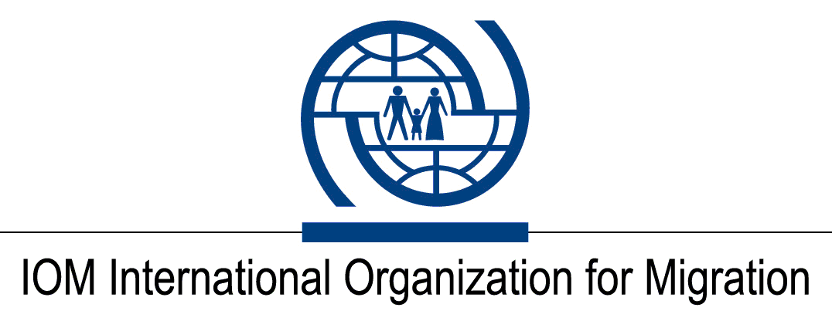

CALL FOR APPLICATIONS
Open to Internal and External Candidates

Position Title | : | Warehouse Assistant
Duty Station | : | Chernivtsi, Ukraine
Classification | : | General Service Staff, UG (1400 USD per month)
Type of Appointment | : | Special Short-Term, Six months with possibility of extension
Estimated Start Date | : | As soon as possible
Closing Date | : | 07 April 2023

Established in 1951, IOM is a Related Organization of the United Nations, and as the leading UN agency in the field of migration, works closely with governmental, intergovernmental and non-governmental partners. IOM is dedicated to promoting humane and orderly migration for the benefit of all. It does so by providing services and advice to governments and migrants.

IOM is committed to a diverse and inclusive environment. Internal and external candidates are eligible to apply to this vacancy. For the purpose of the vacancy, internal candidates are considered as first-tier candidates.

Context:

Under the overall supervision of the Chief of Mission and Supply Chain Officer, and under direct supervision of the Warehouse Officer, the successful candidate will be responsible and accountable for managing the warehouse functions in IOM Ukraine.

Core Functions / Responsibilities:

  - Ensure all warehousing transactions are done in line to IOM internal guidelines and in close coordination with Warehouse Specialist.
  - Coordinate with Warehouse Specialist for receiving, storing, packing, kitting, labelling and dispatch of goods from/to the warehouse.
  - Coordinate with warehousing assistants to make sure all movement of goods are timely recorded.
  - Coordinate with labour and make sure daily timesheet are updated.
  - Plan and organize efficient and safe storing of goods at the warehouse, according to available space and requirements.
  - Ensure that all goods are properly stored and timely registered into the warehouse inventory data base.
  - Responsible for financial aspects related to warehouse and accountable for the stored goods.
  - Maintain records of all transactions, ensuring that an efficient filing system for stock records of all documents are kept.
  - Support the performance of inventory control and assets management, maintain the records and files on assets management, coding and tagging.
  - Prepare daily and weekly progress report for warehousing activities.
  - Act with integrity and professionalism and in accordance with IOM’s Code of Conduct, at all times.
  - Perform such other duties as may be assigned.

Required Qualifications and Experience
Education

- High school diploma or equivalent with at least four years of relevant work experience.
OR
- Bachelor’s Degree or equivalent (preferably in business administration, management or logistics) with at least two years of professional work experience.

Experience
- Experience in warehousing and stock inventory management;
- Excellent level of computer literacy;
- Good knowledge of SAP/PRISM an advantage;
- Experience of work for international organizations is an asset.

Languages

Fluency in English and Ukrainian is required.

The incumbent is expected to demonstrate the following values and competencies:

Values
- Inclusion and respect for diversity: respects and promotes individual and cultural differences; encourages diversity and inclusion wherever possible.
- Integrity and transparency: maintains high ethical standards and acts in a manner consistent with organizational principles/rules and standards of conduct.
- Professionalism: demonstrates ability to work in a composed, competent and committed manner and exercises careful judgment in meeting day-to-day challenges.

Core Competencies – behavioural indicators
- Teamwork: develops and promotes effective collaboration within and across units to achieve shared goals and optimize results.
- Delivering results: produces and delivers quality results in a service-oriented and timely manner; is action oriented and committed to achieving agreed outcomes.
- Managing and sharing knowledge: continuously seeks to learn, share knowledge and innovate.
- Accountability: takes ownership for achieving the Organization’s priorities and assumes responsibility for own action and delegated work.
- Communication: encourages and contributes to clear and open communication; explains complex matters in an informative, inspiring and motivational way.

Other

Any offer made to the candidate in relation to this vacancy notice is subject to funding confirmation.

Appointment will be subject to certification that the candidate is medically fit for appointment and security clearances.

A prerequisite for taking up the position is legal residency in the country of the duty station and work permit, as applicable.

How to apply:

Interested candidates are invited to submit their applications on IOM Personal History Form
to iomukrainerecruitment@iom.int by 07 April 2023 the latest, referring to this advertisement in the subject line of your message.

Only shortlisted candidates will be contacted.

Posting period:
From 30.03.2023 to 07.04.2023

